Binary search trees — properties and representation
Sat, 09 May 26
Binary Search Tree Definition & Properties
- Binary tree where each node follows ordering rule:
  - Left subtree elements < node value
  - Right subtree elements > node value
  - Rule applies recursively to all nodes
- Key properties:
  - No duplicate elements (uses unique keys)
  - In-order traversal produces sorted sequence (ascending)
  - All BSTs are binary trees, but not all binary trees are BSTs
BST Validation Examples
- Valid BST example (root 5):
  - Left subtree: 3, 1, 4 (all < 5)
  - Right subtree: 8, 6, 9 (all > 5)
  - Each internal node satisfies BST property
- Invalid examples:
  - Node 3 with left child 5 (violates left < parent rule)
  - Node 8 with right child 6 (violates right > parent rule)
Formal BST Definition
- Every node contains unique key/element
- Left subtree keys < node key
- Right subtree keys > node key
- Left and right subtrees are also BSTs
- Designed for efficient searching operations
- In-order Traversal happens here
Implementation & Representation
- Array representation inefficient:
  - Wastes memory as tree height increases
  - Many empty cells in skewed trees
- Linked representation preferred:
  - Node structure: element + left reference + right reference
  - Same as binary tree node structure
  - Efficient memory utilization
- BST creation follows binary tree creation with BST insertion rules
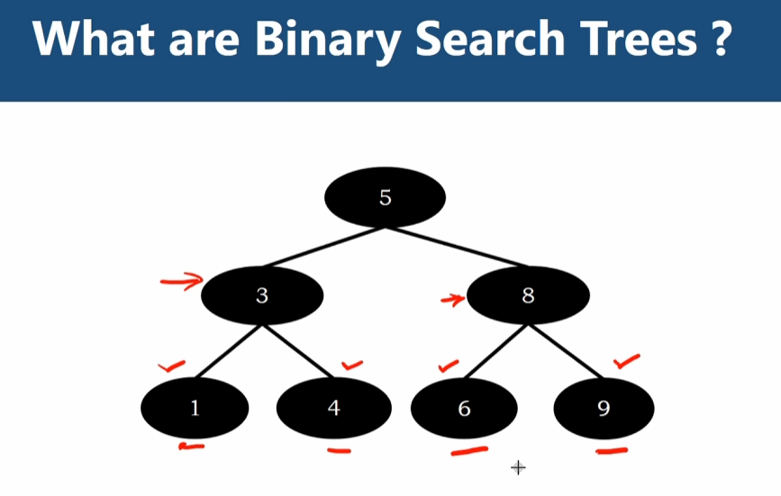
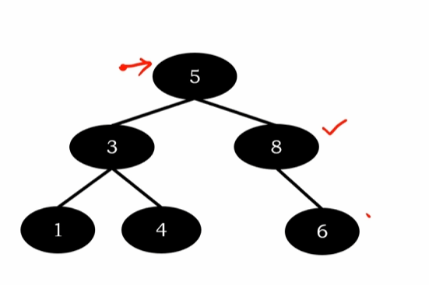

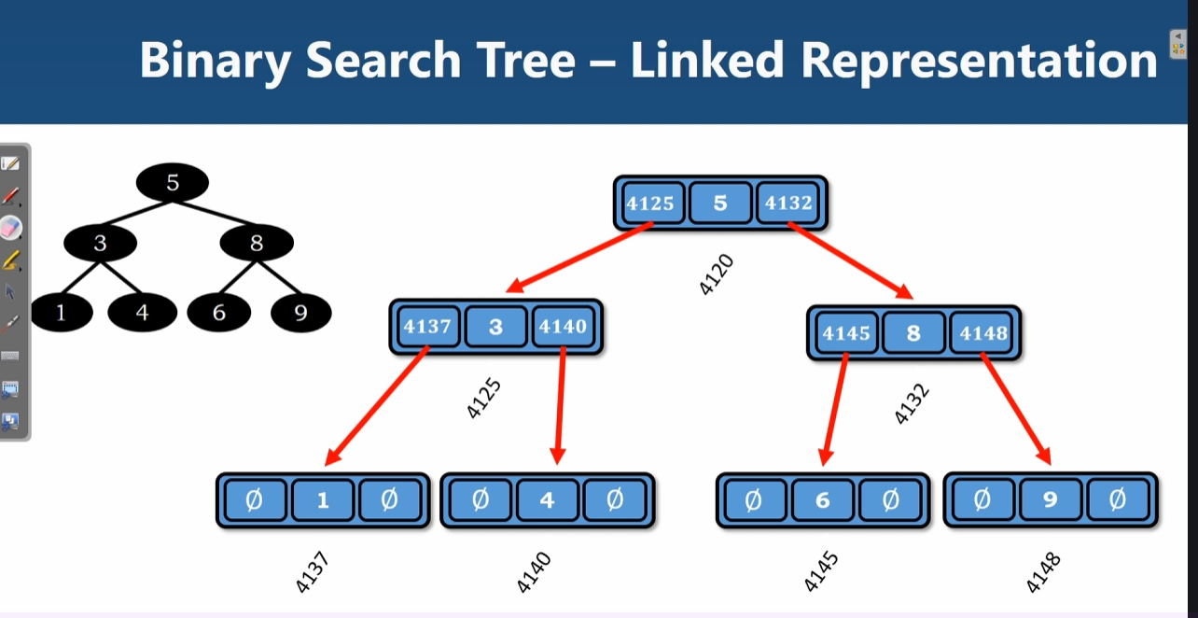

Binary search trees — search operation and time complexity
Sat, 09 May 26
Binary Search Tree Overview
- All elements in left subtree smaller than node
- All elements in right subtree greater than node
- Search operation prerequisite for insertion/deletion operations
Search Algorithm Logic
- Start from root node
- Compare search element with current node:
  - If match found → return true
  - If search element < node element → go to left subtree
  - If search element > node element → go to right subtree
- Continue until element found or reach leaf nodes without match
Search Examples Walkthrough
- Searching element 6:
  - Start at root (5) → 6 > 5, go right
  - Compare with 8 → 6 < 8, go left
  - Find 6 → return true (3 comparisons)
- Searching element 3:
  - Start at root (5) → 3 < 5, go left
  - Find 3 → return true (2 comparisons)
- Searching element 7:
  - Start at root (5) → 7 > 5, go right
  - Compare with 8 → 7 < 8, go left
  - Compare with 6 → 7 > 6, go right
  - No right child exists → return false (4 comparisons)
Time Complexity Analysis
- Best case: Element found at root (O(1))
- Worst case: Element not found or at maximum depth
- Comparisons depend on tree height (h)
- Overall time complexity: O(h) where h = height of BST
- Implementation options: iterative or recursive functions
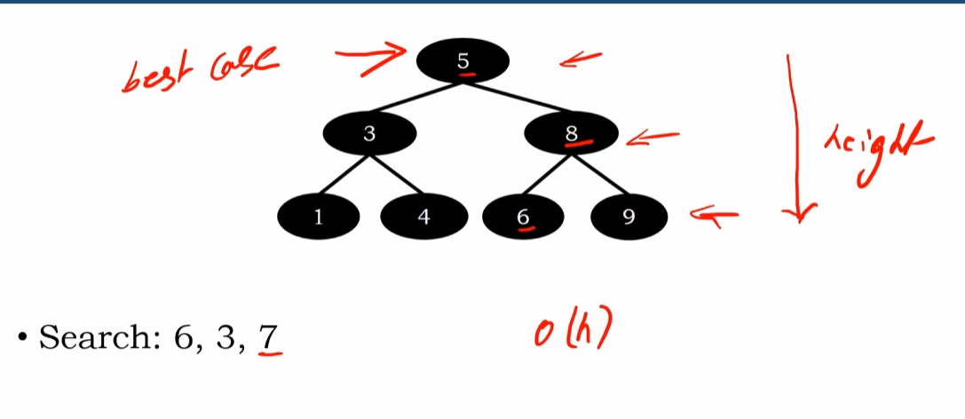

Iterative binary search tree search function — walkthrough and complexity analysis
Sat, 09 May 26
Binary Search Tree Iterative Search Function
- Function structure and setup
  - Takes key parameter for search element
  - Creates temporary root variable (t_root) to hold initial root reference
  - Uses while loop to traverse from root to leaf nodes
- Core algorithm logic
  - Check if key equals current node element → return true if found
  - If key < current element → move to left subtree (t_root = t_root.left)
  - If key > current element → move to right subtree (t_root = t_root.right)
  - Continue until element found or reach leaf node
  - Return false if element not found after full traversal
Search Example: Finding Element 6
- Initial setup: t_root points to root node (5)
- First comparison: 6 ≠ 5, and 6 > 5 → move right to node 8
- Second comparison: 6 ≠ 8, and 6 < 8 → move left to node 6
- Final comparison: 6 = 6 → return true (element found)
Search Example: Finding Element 7 (Not Found)
- Traversal path through tree
  - Start at root (5): 7 > 5 → move right to node 8
  - At node 8: 7 < 8 → move left to node 6
  - At node 6: 7 > 6 → attempt move right, but no right child exists
  - t_root becomes null → exit while loop
- Result: return false (element 7 not found in tree)
Time Complexity Analysis
- Worst case scenario requires comparisons at each tree level
- Number of comparisons depends on tree height
- Time complexity: O(h+1) where h = height of binary search tree
- Simplified to O(h) time complexity
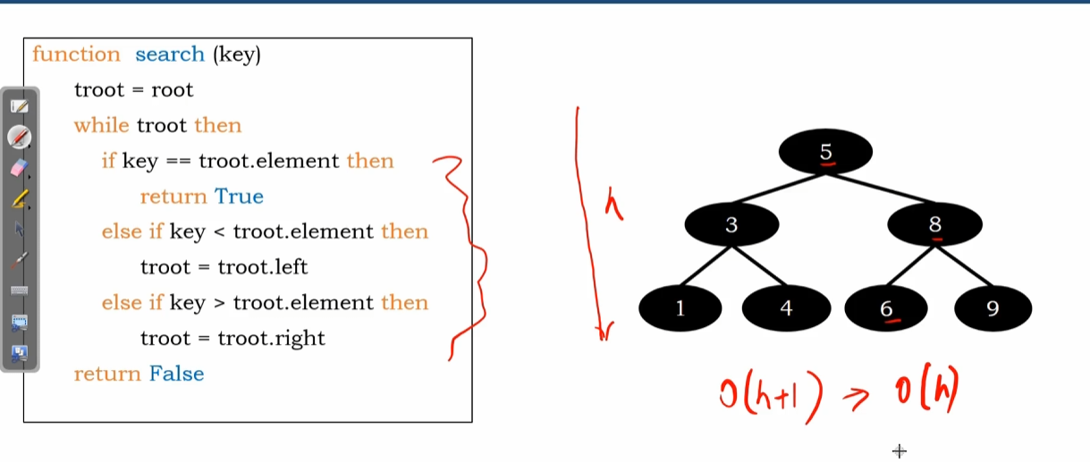

Binary search tree recursive search — algorithm walkthrough
Sat, 09 May 26
Binary Search Tree Recursive Search Function
- Function definition: rsearch(troot, key)
  - First parameter: troot (root of binary search tree)
  - Second parameter: key (element to search for)
Algorithm Logic
- Base case check: if troot (node exists)
  - If key == troot.element: return true (found)
  - If key < troot.element: recursively search left subtree
  - If key > troot.element: recursively search right subtree
- Termination: return false when reaching null pointer (not found)
Example Trace: Searching Element 6
- Starting at root (node 5)
  - 6 ≠ 5, continue
  - 6 > 5, move to right subtree (node 8)
  - 6 ≠ 8, continue
  - 6 < 8, move to left subtree (node 6)
  - 6 = 6, return true
- Result: Element found
Example Trace: Searching Element 7
- Starting at root (node 5)
  - 7 ≠ 5, continue
  - 7 > 5, move to right subtree (node 8)
  - 7 ≠ 8, continue
  - 7 < 8, move to left subtree (node 6)
  - 7 ≠ 6, continue
  - 7 > 6, attempt right subtree (null)
  - Reach null pointer, return false
- Result: Element not found
Time Complexity Analysis
- Recursive calls made at each level of tree
- Total calls: h + 1 (where h = height of tree)
- Time complexity: O(h)
- Performance depends on binary search tree height
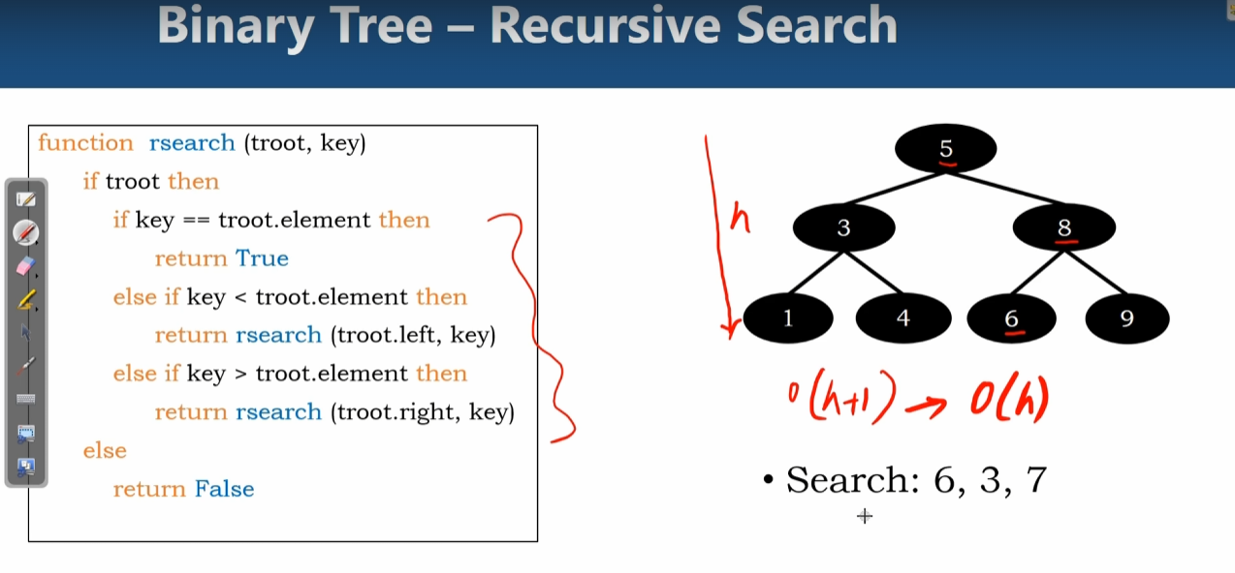

Binary search tree insertion — search, placement, and duplicates
Sat, 09 May 26
Binary Search Tree Insertion Overview
- Insert nodes while maintaining BST property
  - Left subtree elements < node value
  - Right subtree elements > node value
- Process requires searching for correct insertion position first
Insertion Algorithm Steps
- Start from root node and compare insertion value
- Navigate tree based on comparisons:
  - If insertion value < current node → move left
  - If insertion value > current node → move right
  - If insertion value = current node → insertion not allowed (no duplicates)
- Continue until reaching node without required child
- Create new node and attach as appropriate child
Example: Inserting Element 35
- Compare 35 with root (50): 35 < 50 → go left
- Compare 35 with node 30: 35 > 30 → go right
- Compare 35 with node 40: 35 < 40 → go left
- Node 40 has no left child → insert 35 as left child of 40
- BST property maintained after insertion
Example: Inserting Element 72
- Compare 72 with root (50): 72 > 50 → go right
- Compare 72 with node 80: 72 < 80 → go left
- Compare 72 with node 60: 72 > 60 → go right
- Node 60 has no right child → insert 72 as right child of 60
- BST property maintained after insertion
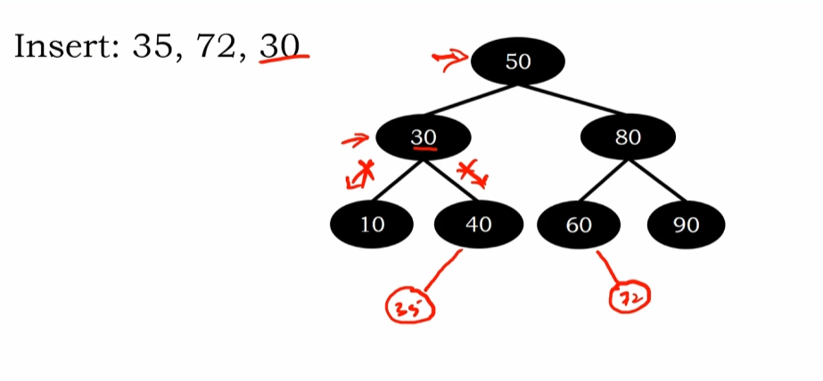
Binary search tree iterative insert — algorithm walkthrough
Sat, 09 May 26
Binary Search Tree Insert Operation Overview
- Iterative function for inserting elements into BST
- Two parameters required:
  - Root reference of the BST
  - Element (e) to insert
- Uses temp variable to track parent node for insertion
Algorithm Implementation Steps
- Initial setup:
  - temp = null (stores parent reference)
  - while loop condition: t_root ≠ null
- Search process within while loop:
  - temp = t_root (track current node as potential parent)
  - Check if element equals current node element
    - If true: return (no duplicates allowed)
  - Navigate based on comparison:
    - If e < current element: move to left subtree
    - If e > current element: move to right subtree
- Loop continues until t_root becomes null (insertion point found)
Node Creation and Insertion Logic
- Create new node after finding insertion position
- Check if BST has existing root:
  - If root exists:
    - Compare element with parent (temp node)
    - Insert as left child if e < parent element
    - Insert as right child if e > parent element
  - If no root exists:
    - Assign new node as root of empty BST
Practical Example: Inserting Element 35
- Starting BST with root node 50
- Trace execution:
  - t_root points to node 50, temp = null
  - 35 < 50 → move to left child (node 30)
  - temp points to node 50, t_root points to node 30
  - 35 > 30 → move to right child (node 40)
  - temp points to node 30, t_root points to node 40
  - 35 < 40 → attempt left move, but no left child exists
  - t_root becomes null, temp points to node 40 (parent)
  - Create new node with element 35
  - Insert as left child of node 40
Time Complexity Analysis
- Search operation dominates complexity
- Worst case: O(h + 1) comparisons where h = tree height
- Node creation and insertion: O(1) primitive operations
- Overall time complexity: O(h) where h is BST height
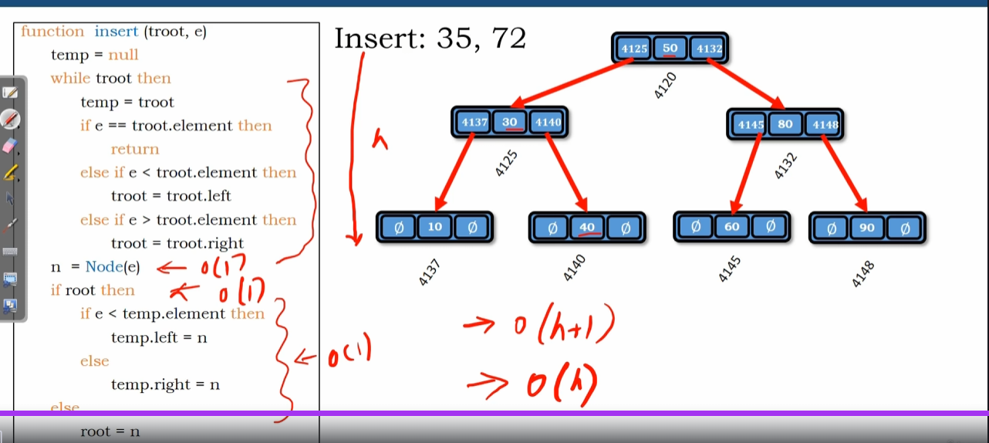

Binary search tree — recursive insert operation
Sat, 09 May 26
Binary Search Tree Recursive Insert Function
- Function name: r_insert with parameters root and element e
- Uses recursive approach to find insertion position
- Returns reference to modified tree structure
Algorithm Logic
- Base case: if root is null, create new node and return
- Recursive cases:
  - If e < root.element: recursively call on left subtree
  - If e > root.element: recursively call on right subtree
- Returned references update left/right child pointers automatically
Step-by-Step Example (Inserting 35)
- Start at root (node 50)
  - 35 < 50, go left to node 30
- At node 30
  - 35 > 30, go right to node 40
- At node 40
  - 35 < 40, go left (null position)
- Create new node with element 35
  - Assign as left child of node 40
  - Return references propagate back up call stack
Time Complexity Analysis
- Depends on height of binary search tree
- Number of comparisons: h + 1 (where h = height)
- Overall complexity: O(h)
- Primitive operations take constant time
- Same complexity pattern as search operation
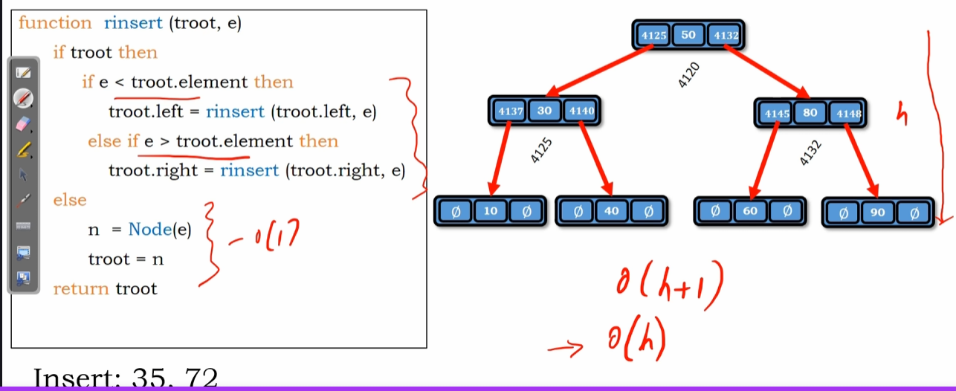

Binary search tree traversals — in-order, pre-order, post-order, and level-order
Sat, 09 May 26
Binary Search Tree Traversal Overview
- Four traversal methods apply to BSTs (same as binary trees)
- In-order traversal produces sorted sequence in BSTs
- Each method visits nodes in different order patterns
In-Order Traversal
- Visit sequence: left subtree → root → right subtree
- Example path: 10 → 13 → 40 → 50 → 60 → 80 → 90
- Key property: results in sorted order for BSTs
  - Left subtree: 10, 13, 40
  - Root: 50
  - Right subtree: 60, 80, 90
Pre-Order and Post-Order Methods
- Pre-order traversal (root first):
  - Visit sequence: 50 → 30 → 10 → 40 → 80 → 60 → 90
  - Pattern: root → left subtree → right subtree
- Post-order traversal (root last):
  - Visit sequence: 10 → 40 → 30 → 60 → 90 → 80 → 50
  - Pattern: left subtree → right subtree → root
Level-Order Traversal
- Visits nodes level by level from top to bottom
- Example sequence: 50 → 30, 80 → 10, 40, 60, 90
- Process by levels:
  - Level 1: 50 (root)
  - Level 2: 30, 80
  - Level 3: 10, 40, 60, 90
In-order binary tree traversal — recursive algorithm walkthrough
Sat, 09 May 26
Binary Tree In-Order Traversal Function
- Function definition: inorder(t_root)
  - Parameter t_root represents temporary root object
  - Prevents manipulation of actual binary tree root
  - Maintains reference to entire tree structure
Recursive Algorithm Structure
- Base condition check: if t_root (non-empty validation)
- Three-step traversal process:
  - Recursively visit left subtree (t_root.left)
  - Print current root element
  - Recursively visit right subtree (t_root.right)
- Execution continues until all nodes visited in in-order fashion
Step-by-Step Trace Example
- Starting node: A (root of binary tree)
- Traversal sequence demonstrated:
  - A → C → F (leftmost path)
  - F printed (no left child, no right child)
  - C printed (left subtree complete, no right child)
  - A printed (left subtree complete)
  - A → E → H (right subtree path)
  - H printed (no children)
  - E printed (left subtree complete)
  - E → I (right child)
  - I printed (no children)
Final Output Order
- Complete in-order traversal result: F, C, A, H, E, I
- Demonstrates left-root-right visiting pattern
- All recursive calls properly terminate when subtrees are empty/null
